**Car Theft Alert System**

**Project Description Report**

**1. Introduction**

Car theft is a global issue causing financial losses and emotional distress. Traditional car alarm systems are often ineffective as they rely solely on loud alarms, which may go unnoticed. The *Car Theft Alert System* is a smart and innovative security solution designed to address this issue by integrating motion detection, real-time alerts, and cloud-based evidence storage.

The system leverages modern hardware and software technologies, including Raspberry Pi, STM32 microcontroller, and LD2410 radar sensor, to provide real-time monitoring and user notifications, ensuring robust vehicle security.

**2. Objectives**

The primary objectives of this project are:

1. To detect unauthorized movement near a parked vehicle using advanced sensors.
2. To capture real-time evidence (images) of potential threats.
3. To send instant notifications to the vehicle owner with proof via SMS.
4. To provide a cost-effective, user-friendly, and scalable car security solution.

**3. System Design**

**3.1 Components**

1. **Raspberry Pi**:
   * Acts as the central processing unit for the system.
   * Interfaces with the camera, keypad, buttons, and APIs for notifications.
2. **STM32 Microcontroller**:
   * Processes distance data from the LD2410 radar sensor.
   * Determines if the distance threshold (30 cm) is breached.
   * Sends a signal to Raspberry Pi upon intrusion detection.
3. **LD2410 Radar Sensor**:
   * A motion-detection sensor capable of accurately measuring distances.
   * Monitors the surroundings for objects within a specified range.
4. **Camera**:
   * Captures images of potential intruders.
5. **Keypad and Buttons**:
   * **Start Button**: Activates the system.
   * **Stop Button**: Deactivates the system.
   * **Arm Button**: Validates passcode input for security.
6. **Cloud Integration (Dropbox)**:
   * Stores captured images securely and generates sharable links.
7. **SMS API (e.g., Twilio)**:
   * Sends alert messages with evidence links to the user’s phone.

**3.2 Workflow**

1. **Arming the System**:
   * The user presses the *Start* button and inputs a passcode on the keypad.
   * The Raspberry Pi activates a GPIO pin, signaling the STM32 to start monitoring.
2. **Motion Detection**:
   * The LD2410 sensor continuously measures distance to detect nearby objects.
   * The STM32 microcontroller analyzes the sensor data to check if an object is within 30 cm of the vehicle.
3. **Intrusion Alert**:
   * If an object breaches the 30 cm threshold, STM32 signals the Raspberry Pi.
   * The Raspberry Pi triggers the camera to capture an image.
4. **Image Upload and Notification**:
   * The captured image is uploaded to Dropbox.
   * A sharable link to the image is generated and sent to the user via SMS.

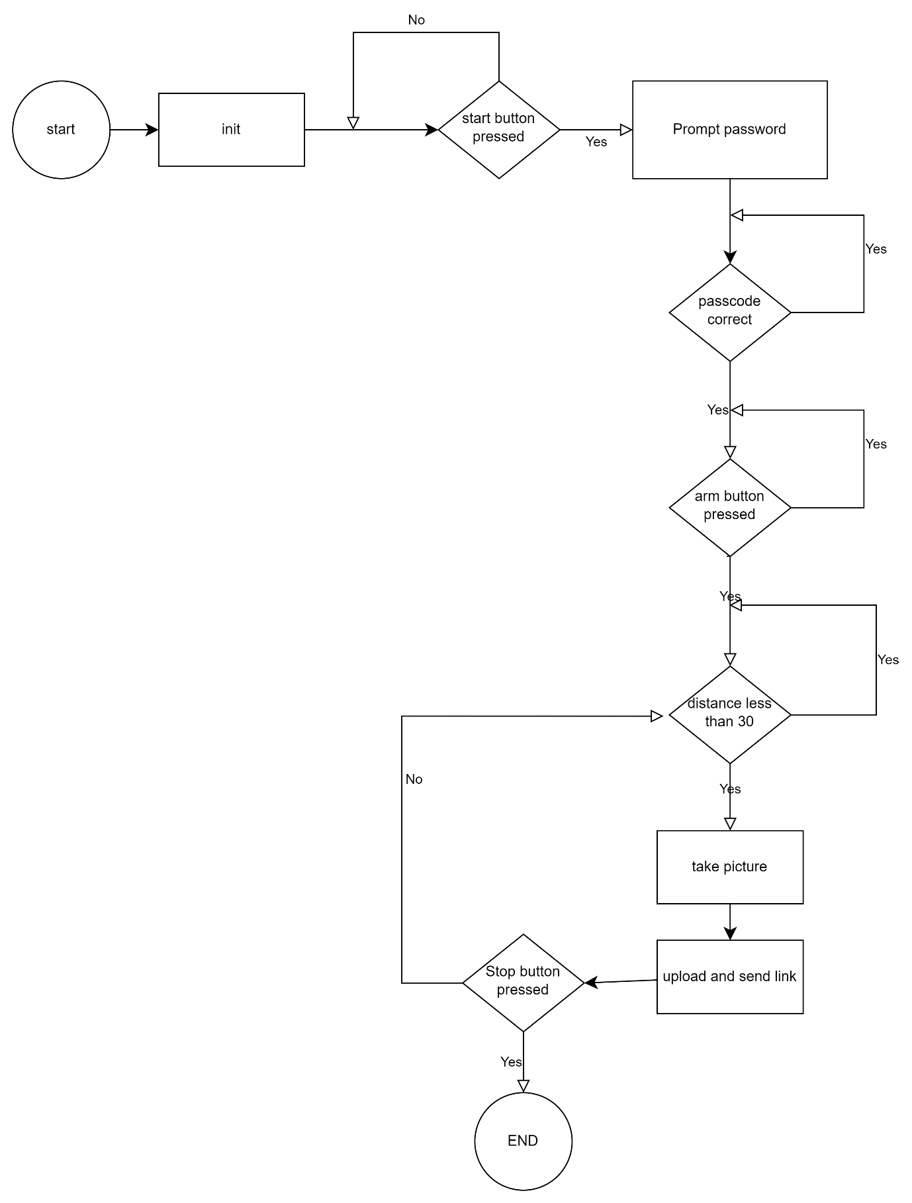

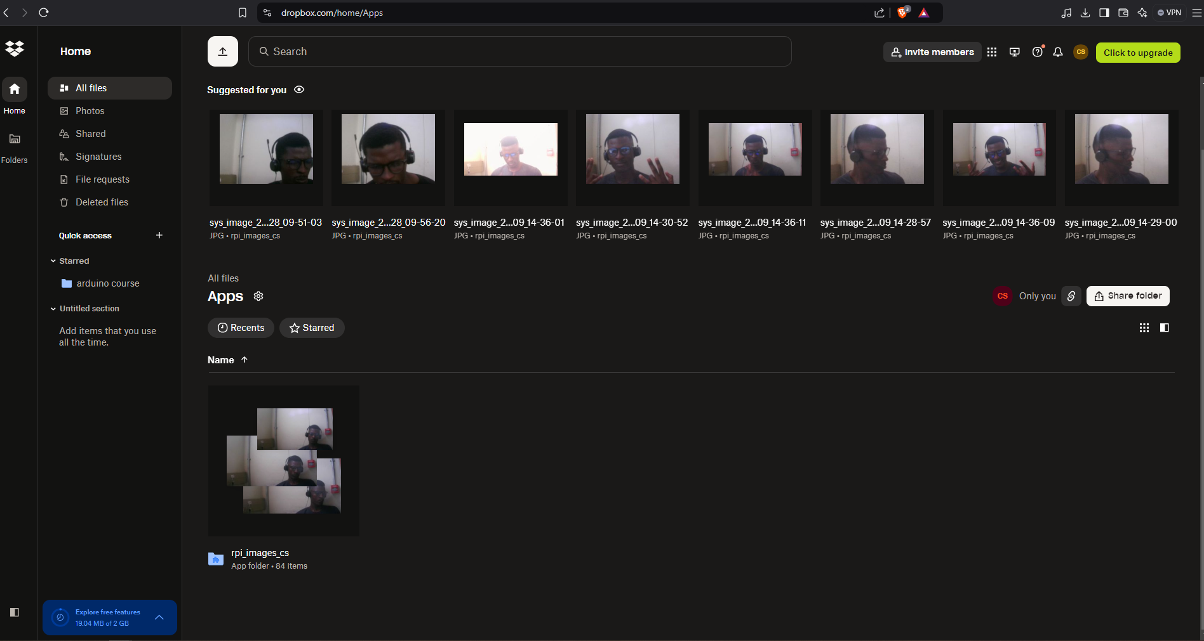

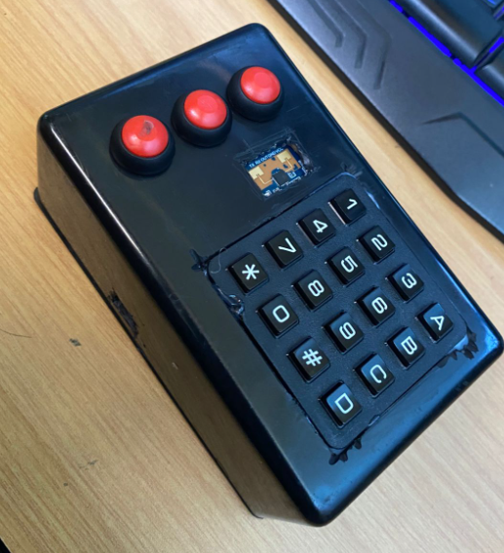

**4. Features**

1. **Real-Time Detection**:
   * Continuous monitoring for unauthorized activity near the vehicle.
2. **Passcode Protection**:
   * Ensures only authorized users can arm or disarm the system.
3. **Evidence Collection**:
   * Captures images of potential intruders for verification and legal use.
4. **Instant Alerts**:
   * Sends SMS notifications with proof to the user, ensuring timely action.
5. **Cloud Storage**:
   * Stores captured evidence securely in Dropbox.

**5. Benefits**

1. **Enhanced Security**:
   * Combines motion detection, evidence capture, and instant alerts for robust car protection.
2. **Cost-Effective**:
   * Uses affordable hardware components with minimal maintenance costs.
3. **Ease of Use**:
   * Simple arming and disarming process with a user-friendly interface.
4. **Scalability**:
   * Can be expanded to include additional sensors or functionalities.

**6. Applications**

1. **Personal Vehicles**:
   * Ideal for private car owners seeking additional security.
2. **Fleet Monitoring**:
   * Real-time protection for commercial fleets in parking lots.
3. **Public Parking Areas**:
   * Enhances the security of vehicles in shared parking spaces.

**7. System Architecture**

The architecture includes the following key modules:

1. **Input Module**:
   * User inputs passcode through a keypad.
   * Activation buttons signal Raspberry Pi.
2. **Processing Module**:
   * STM32 processes distance data and sends alerts to Raspberry Pi.
3. **Action Module**:
   * Raspberry Pi captures images, uploads them to Dropbox, and sends SMS alerts.
4. **Notification Module**:
   * Uses APIs to notify users with real-time alerts.

**8. Technical Implementation**

**Hardware Setup:**

* Raspberry Pi GPIO pins connected to:
  + Keypad and buttons for user interaction.
  + Camera for image capture.
  + STM32 for receiving intrusion alerts.
* STM32 interfaces with the LD2410 radar sensor to process distance data.

**Software Implementation:**

* **Raspberry Pi**:
  + Python scripts to control GPIO pins, capture images, and integrate Dropbox and SMS APIs.
* **STM32**:
  + Embedded C code to process LD2410 data and send intrusion alerts.
* **Cloud APIs**:
  + Dropbox API for secure image storage and link generation.
  + SMS API (e.g., Twilio) for real-time notifications.

**9. Limitations and Future Enhancements**

**Limitations:**

1. Limited detection range based on the LD2410 sensor.
2. SMS notifications dependent on internet connectivity.

**Future Enhancements:**

1. **Real-Time Video Streaming**:
   * Add a video feed for live monitoring.
2. **Multi-Sensor Integration**:
   * Incorporate additional sensors like ultrasonic or PIR for enhanced detection.
3. **Local Alarms**:
   * Include an audible alarm to deter intruders.

**10. Conclusion**

The *Car Theft Alert System* offers a reliable, real-time, and cost-effective solution for vehicle security. By combining motion detection, evidence collection, and instant user notifications, the system significantly enhances the safety of parked vehicles. With future enhancements, the system can become an indispensable tool for preventing car thefts in personal and public spaces.

This report provides a comprehensive overview of the project, from its objectives to technical implementation and future possibilities. Let me know if you need further details or specific sections expanded!